SALESFORCE-SUPPORTED VIRTUAL INTERNSHIP PROGRAM 2025
PROJECT: WhatNext Vision Motors: Shaping the Future of Mobility with Innovation and Excellence

NAME: Seetha Lokesh
DEPARTMENT: CSE
COLLEGE NAME: SRM UNIVERSITY, AP
COLLEGE MAIL:lokesh_seetha@srmap.edu.in
TRAILBLAZER_LINK:https://www.salesforce.com/trailblazer/s2fuutjthfmxu1lwwl
DATE: 27/07/2025

Acknowledgement :

I would like to express my heartfelt gratitude to Salesforce for the opportunity to participate in the 2025 Virtual Internship Program. This project allowed me to gain hands-on experience with powerful Salesforce tools that are revolutionizing the way businesses interact with customers.
A special thanks to my mentor and the Trailhead community, whose support and feedback played a key role in successfully completing this project. I also extend my sincere appreciation to my faculty at SRM University, AP, for their continuous encouragement throughout this journey.

Project Overview:
The project titled "WhatNext Vision Motors: Shaping the Future of Mobility with Innovation and Excellence" focuses on digital transformation within the automotive sector using Salesforce CRM. The primary goal was to enhance the customer ordering experience, automate dealer assignment, and improve inventory visibility.
Key business challenges addressed include:
- Assigning customers to the nearest dealership automatically based on their address.
- Preventing customers from placing orders for vehicles that are out of stock.
- Automating bulk order status updates based on real-time stock availability.
By leveraging Salesforce features like Record-Triggered Flows, Apex Triggers, and Batch Apex Jobs, the system delivers operational efficiency, reduced manual work, and enhanced customer satisfaction.

Objectives :
The primary objectives of this project include:
- Automate vehicle ordering and dealer assignment.
- Prevent orders for unavailable stock to enhance reliability.
- Ensure order statuses are automatically updated based on stock levels.
- Enhance operational productivity with automation.
- Provide customers with real-time, transparent order updates.
Key Goals:
- Build an order management system integrated with dealer and stock data.
- Implement business logic with Apex for stock validation and assignment.
- Enable scheduled jobs for batch order processing.
- Create automated alerts for test drives and stock updates.

Technology Description :
The project was implemented using Salesforce, a cloud-based CRM platform offering declarative tools and programmatic capabilities to build scalable, automated business applications.
Tools & Components Used:
- Custom Objects: For vehicles, dealers, orders, and customers.
- Lightning App Builder: To create a centralized app for all stakeholders.
- Record-Triggered Flows: For dealer assignment and order validations.
- Apex Triggers: To enforce custom business rules for order creation and stock_checks.
- Batch Apex Jobs: For scheduled stock validation and bulk order status updates.
- Scheduled Apex: To automate status updates and notifications.
- Validation Rules: To maintain data integrity and avoid invalid entries.
- Email Alerts: For test drive reminders and stock updates.

Detailed Explanation of the project :
This project was executed in well-defined phases using the Salesforce platform. Each phase involved specific tools and features that contributed to building an efficient and scalable plastic recycling management system. Below is a step-by-step explanation of how each part was implemented.

Phase 1: Developer Org Setup
A new Salesforce Developer Org was set up to build and test the application in a sandbox environment without affecting live data.
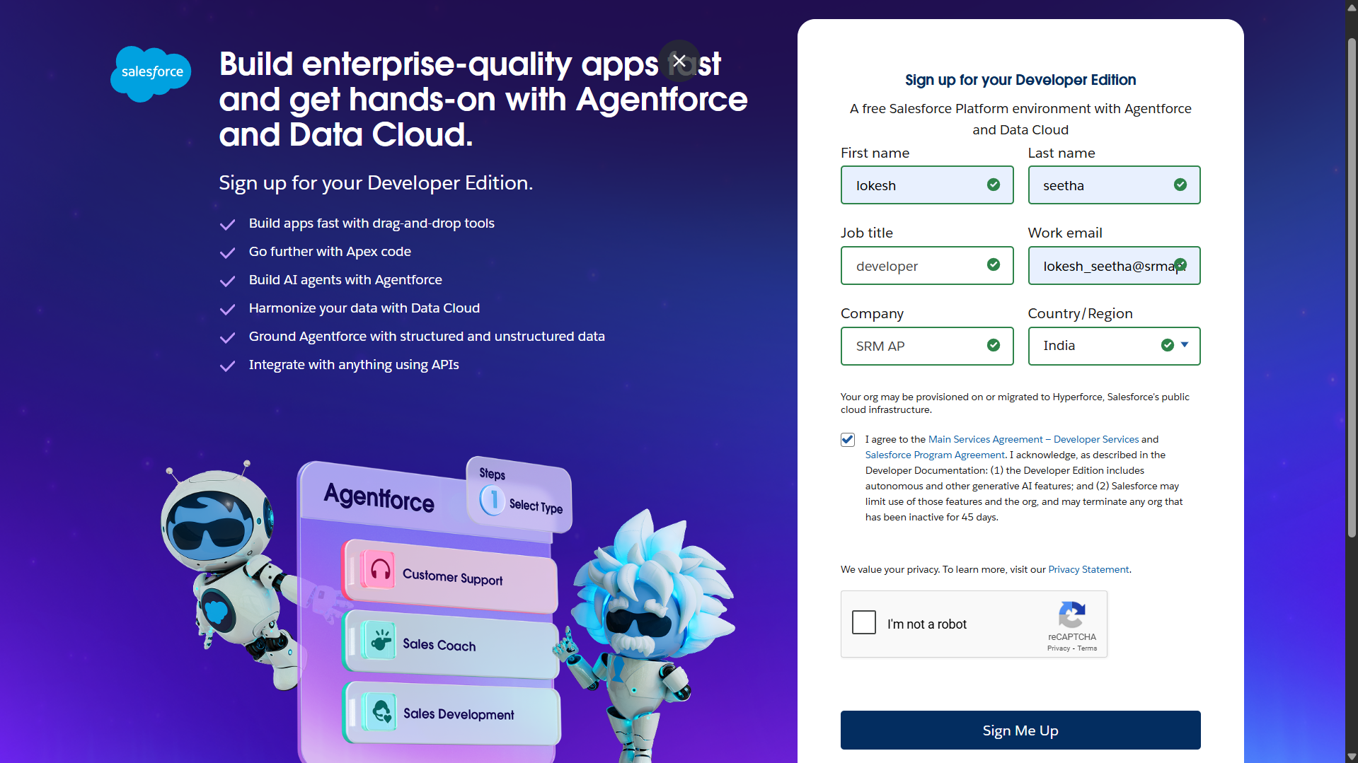

Phase 2: Object & Data Modeling
Custom objects were created to represent:
- Vehicle
- Vehicle Customer
- Vehicle Service Request
- Vehicle Test Drive
- Vehicle Order
- Vehicle Dealer
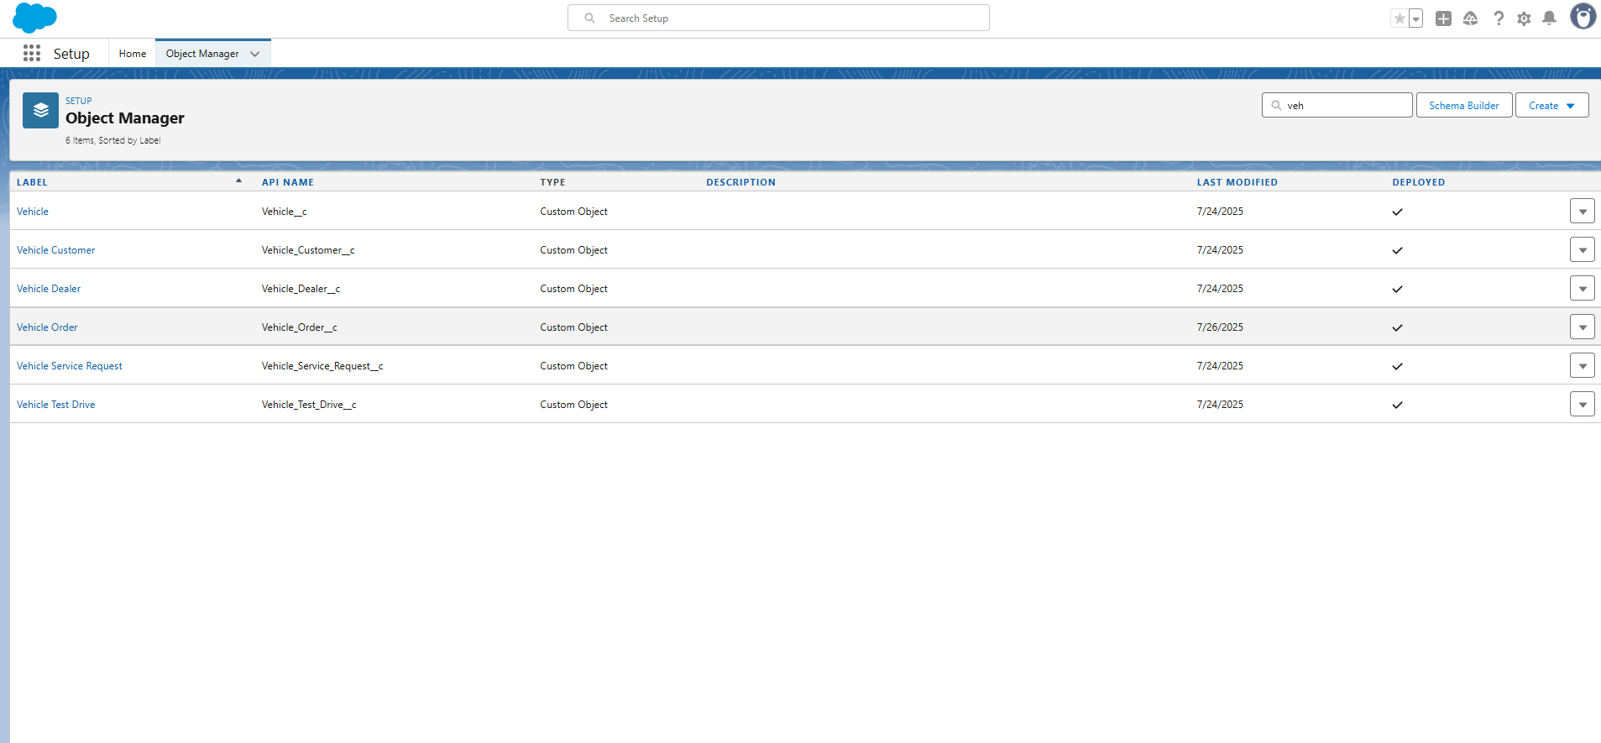

Phase 3: Record-Triggered Flows
Automates dealer assignment and sends confirmation emails.

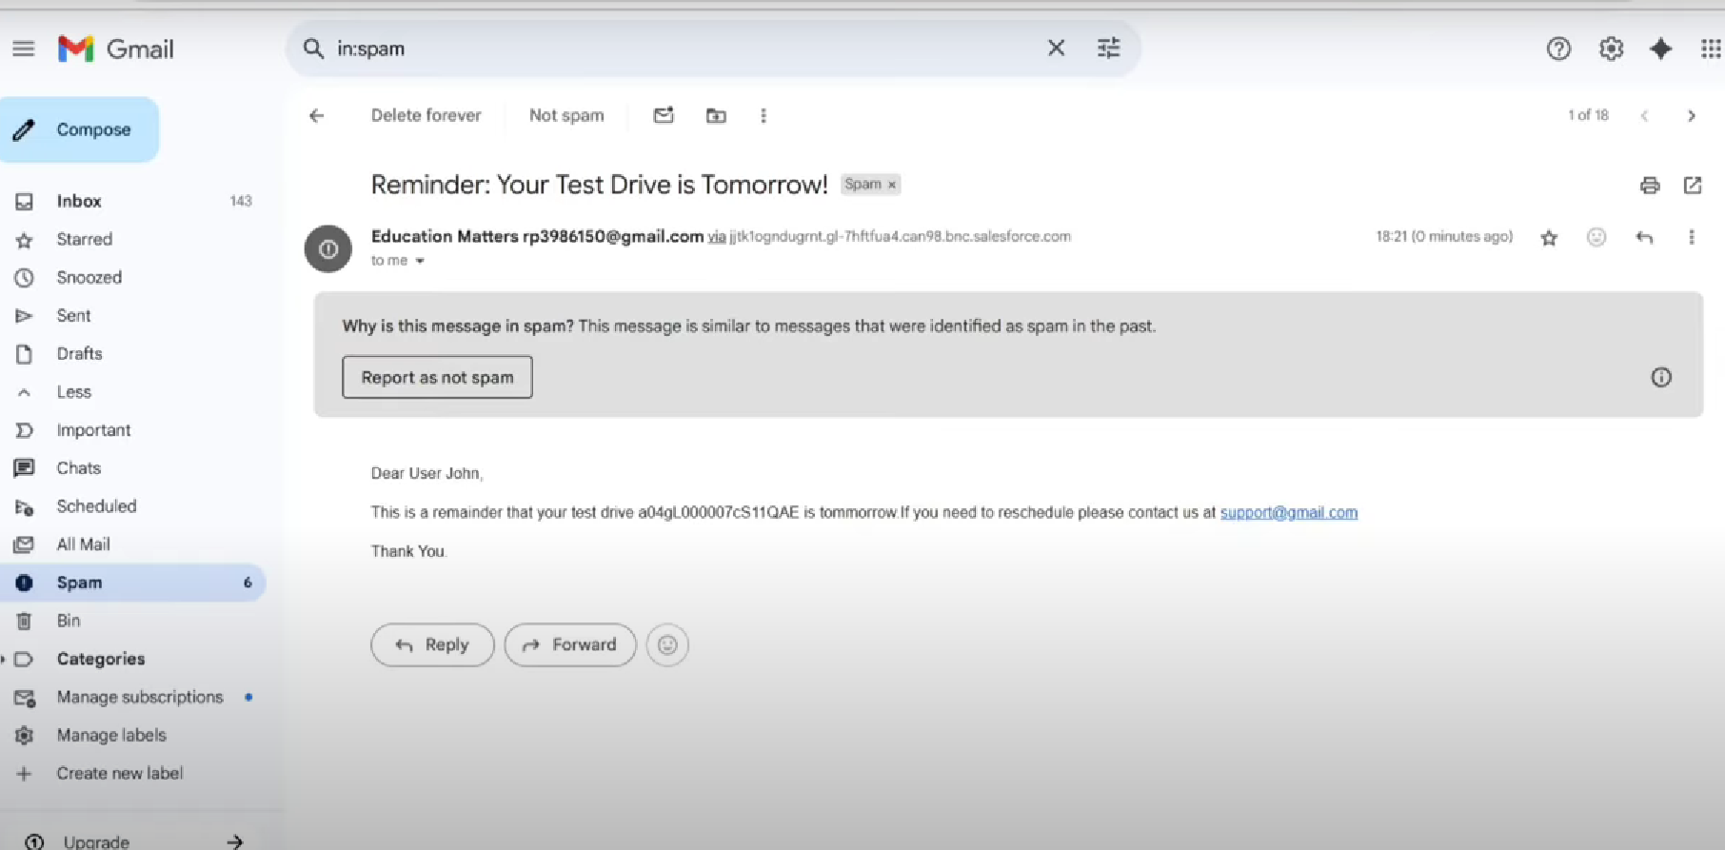
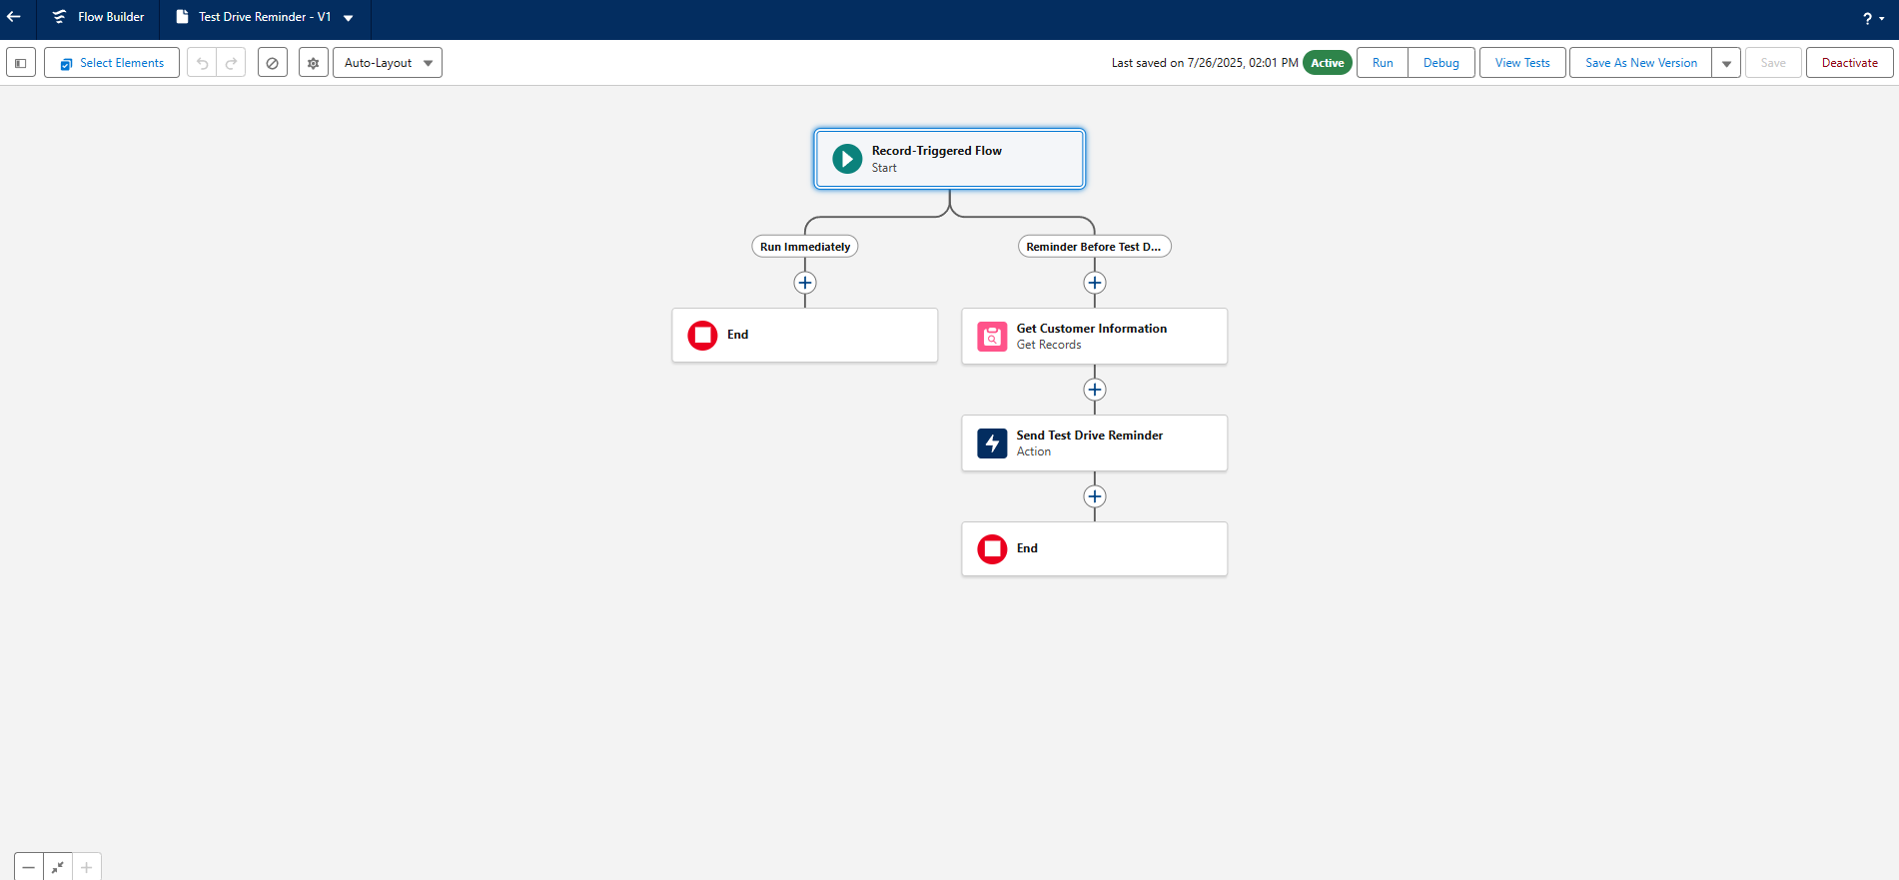

Phase 4: Stock Availability Check
Apex logic prevents order creation for vehicles that are out of stock.
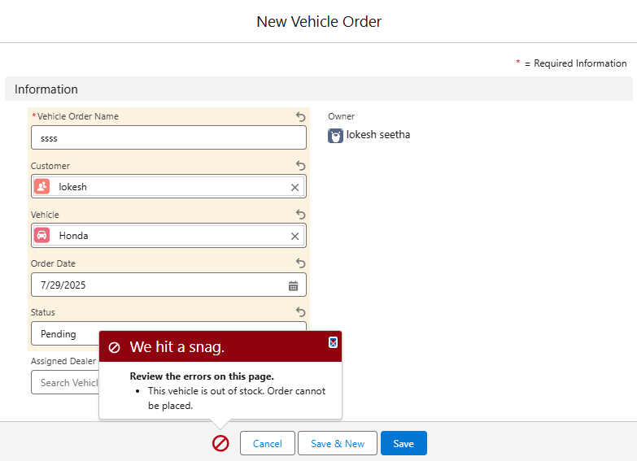

Phase 5: Apex Triggers and Handlers
Handles stock deduction, order status updates, and uses trigger handlers for clean code.

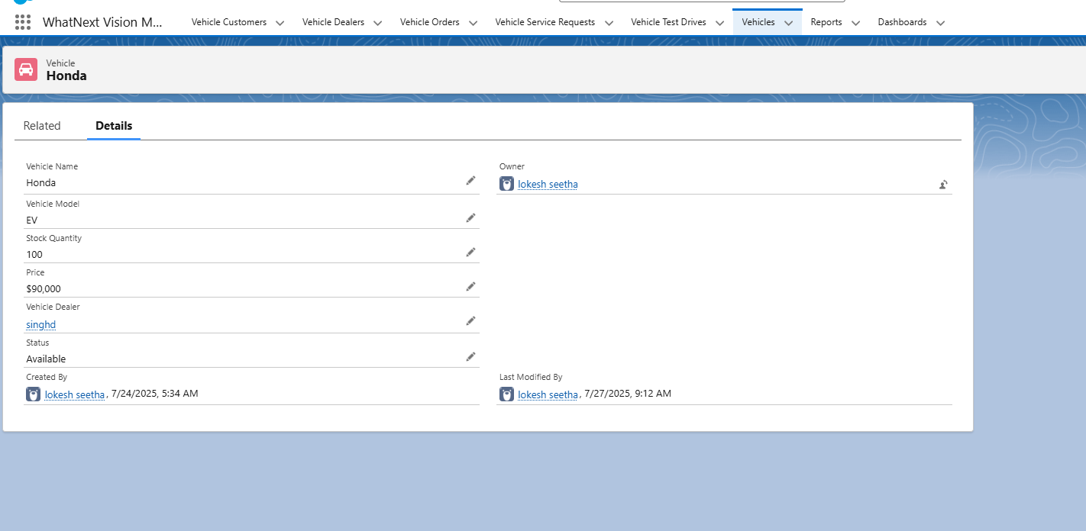

Phase 6: Batch Apex Job for Bulk Updates
Nightly batch job checks order records and updates statuses, sending email alerts as needed.
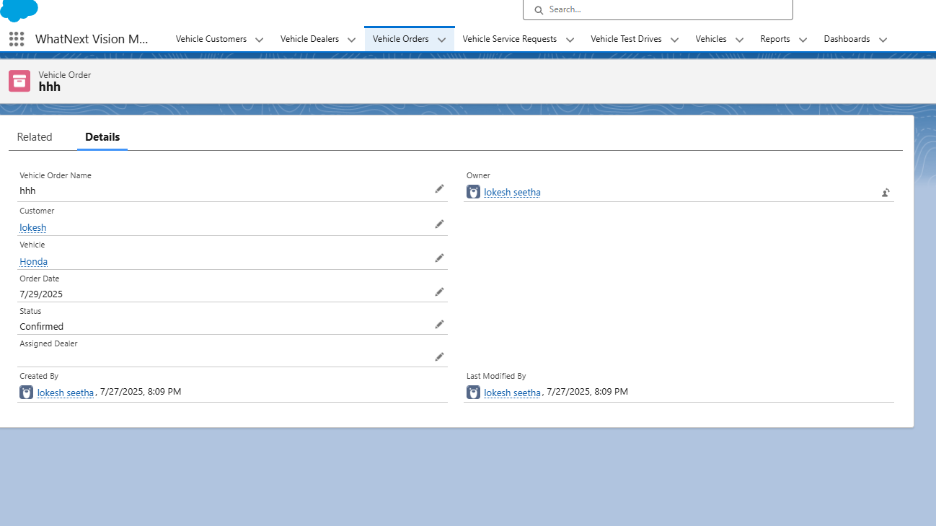
Stock Quantity changed from 100 to 99 after ordering vehicle
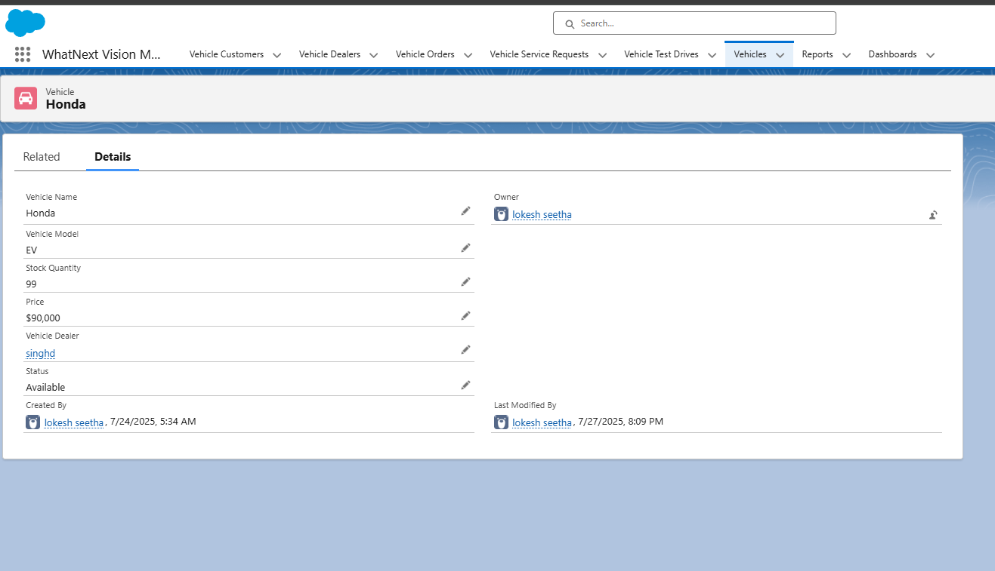
Phase 7: Lightning App & UI Setup
A Lightning App “Vision Motors CRM” includes all objects with role-based UI access.

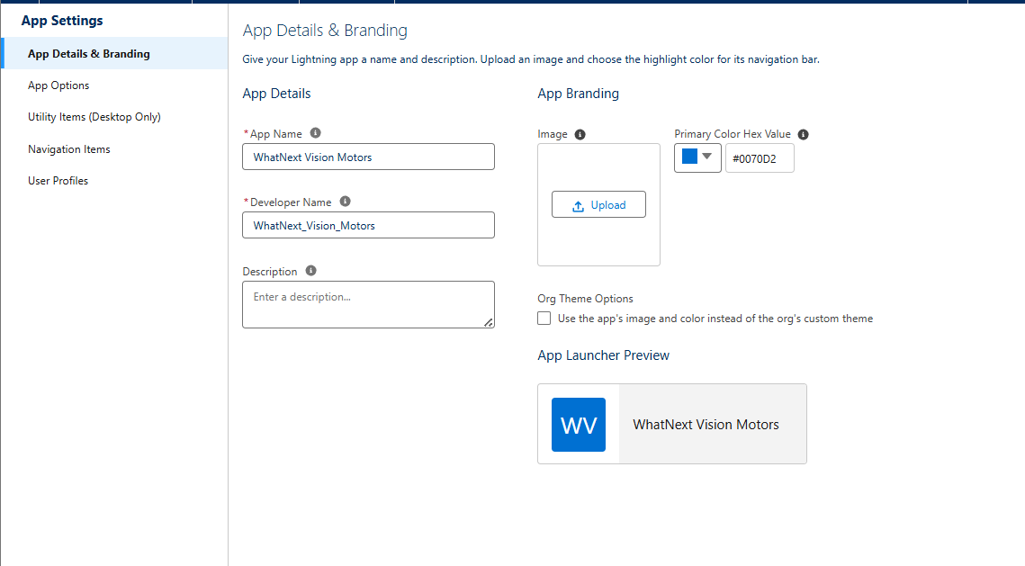

Conclusion
The Salesforce-based project at WhatNext Vision Motors demonstrates how CRM and automation can transform traditional automotive business processes. By automating dealer assignments, validating stock availability, and updating order statuses in real time, the system provides a seamless experience for both customers and internal staff.
The use of declarative tools combined with programmatic logic ensured high flexibility, easy maintenance, and better operational performance. Ultimately, this project aligns with the company’s mission to lead innovation and customer excellence in the evolving mobility landscape.

Future Scope
To scale and future-proof the application, the following enhancements are proposed:
- Chatbot Integration: Enable customers to check order status and book test drives via a Salesforce chatbot.
- Mobile App Version: For field agents to track customer orders and update delivery status on the go.
- AI Forecasting: Predict vehicle demand and restock requirements using Salesforce Einstein AI.
- API Integration: Connect with external logistics providers and inventory systems.
- Geolocation Services: Refine dealer assignment using real-time GPS and traffic data.
- Customer Portal: A secure Experience Cloud portal for customers to manage their orders, payments, and service history.
These features would make the system more intelligent, accessible, and scalable for a rapidly evolving automotive industry.

